**DAILY ONLINE ACTIVITIES SUMMARY**

|  |  |  |  |  |  |  |  |  |
| --- | --- | --- | --- | --- | --- | --- | --- | --- |
| **Date:** | **18/05/2020** | | | | | **Name:** | **Arun K** | |
| **Sem & Sec** | **VI ‘A’** | | | | | **USN:** | **4AL17CS013** | |
| **Online Test Summary** | | | | | | | | |
| **Subject** | | **CNSC** | | | | | | |
| **Max. Marks** | | **60** | | **Score** | | | **43** | |
| **Certification Course Summary** | | | | | | | | |
| **Course** | **Python and Ethical hacking** | | | | | | | |
| **Certificate Provider** | | | **Udemy** | | **Duration** | | | **1 month** |
| **Coding Challenges** | | | | | | | | |
| **Problem Statement:** <https://github.com/ArunKumar9538/Alvas_onlione_coading/blob/master/README.md> | | | | | | | | |
| **Status: done** | | | | | | | | |
| **Uploaded the report in Github** | | | | | **yes** | | | |
| **If yes Repository name** | | | | | https://github.com/ArunKumar9538/Alvas_onlione_coading.git | | | |
| **Uploaded the report in slack** | | | | | **yes** | | | |

Online Test Details: (Attach the snapshot and briefly write the report for the same)

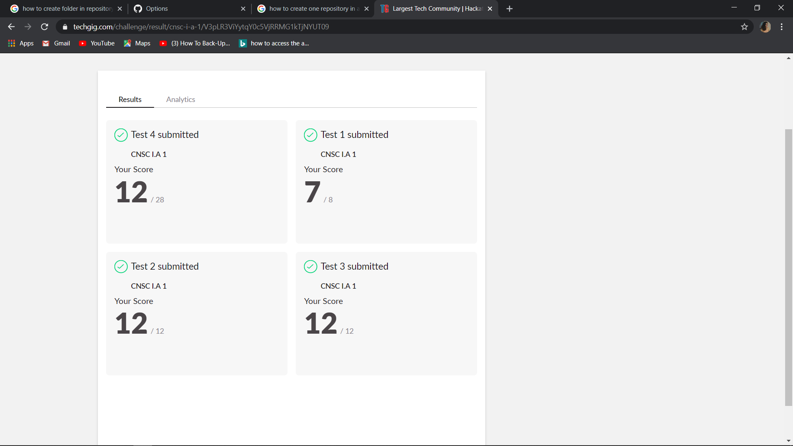

Certification Course Details: (Attach the snapshot and briefly write the report for the same)

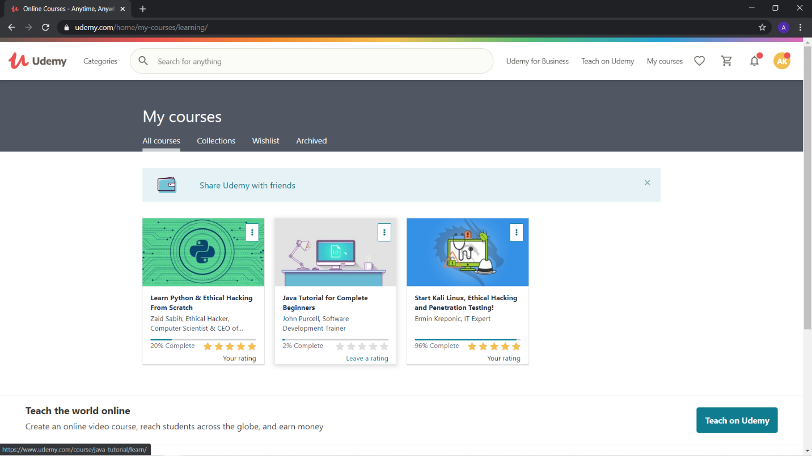

Introduction about the ethical hacking installation of virtual box and method of adding the virtual machine to the virtual box